Process Amazon S3 Events with AWS Lambda
Open S3
- Go to AWS Console
- Search for S3
- Click Create bucket
- • Keep Block Public Access ON
- • Click Create bucket

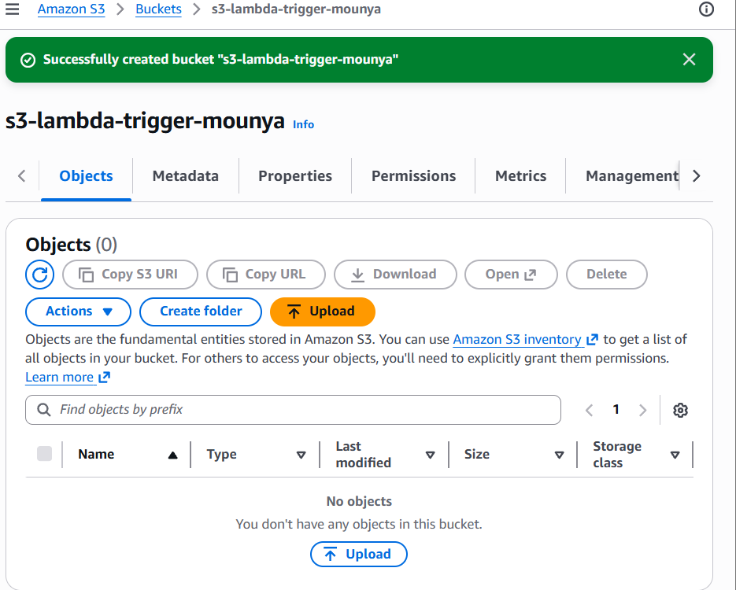

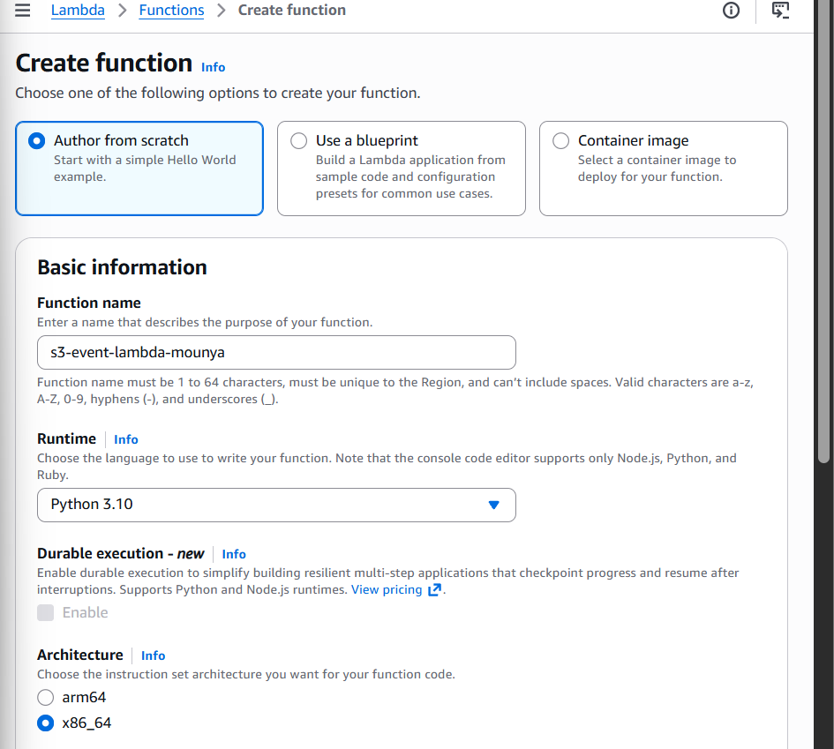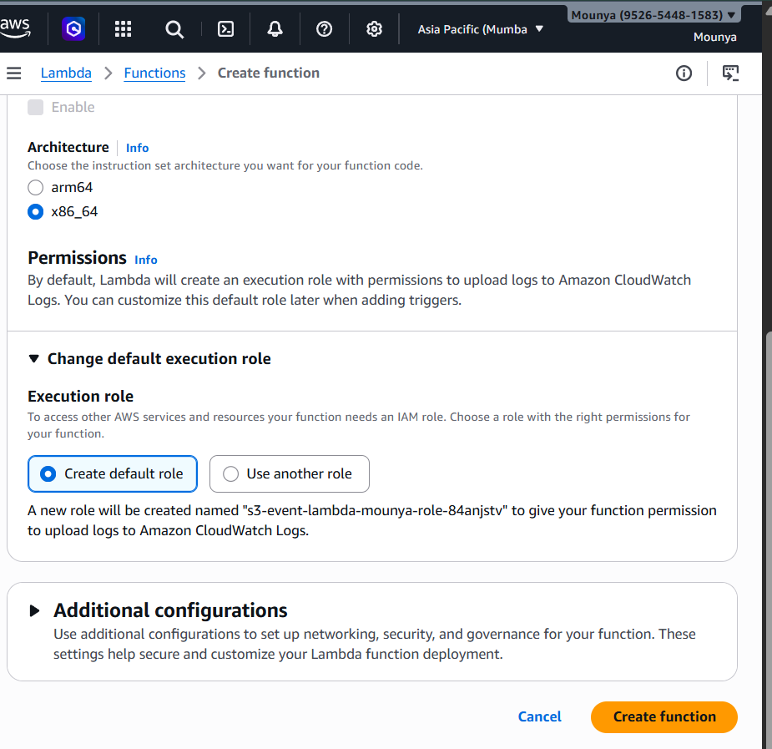

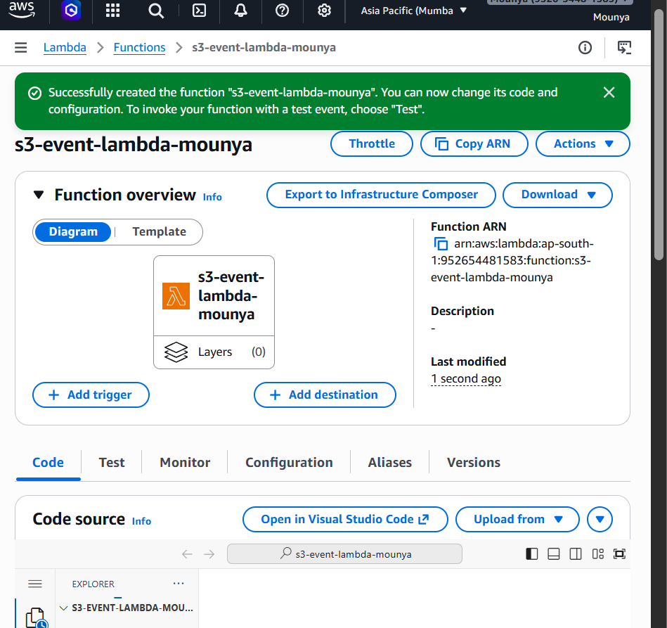

Add trigger
- In the Lambda function page
- Click Add trigger
Configure trigger
- Bucket → select your created S3 bucket
- Event type → All object create events
- ✅ Tick I acknowledge…
- Enable trigger ✅
- Click Add
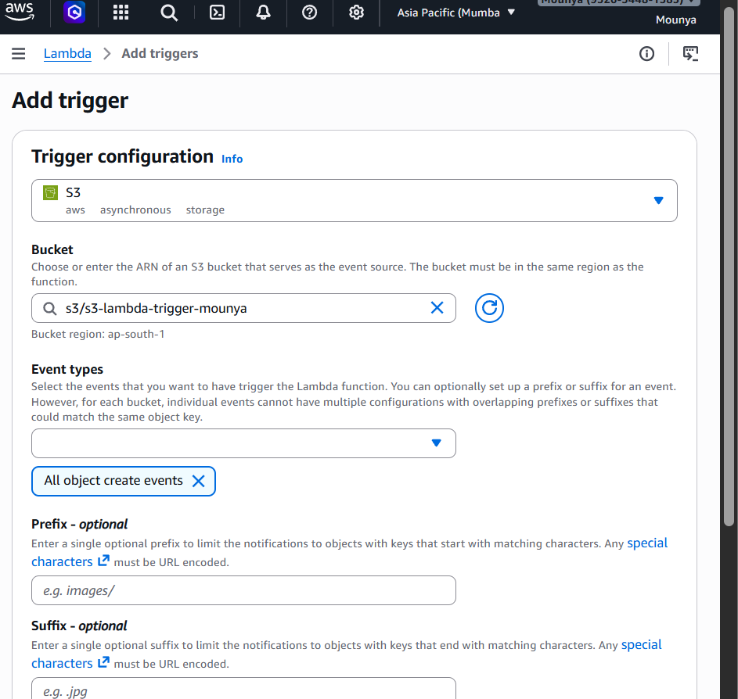

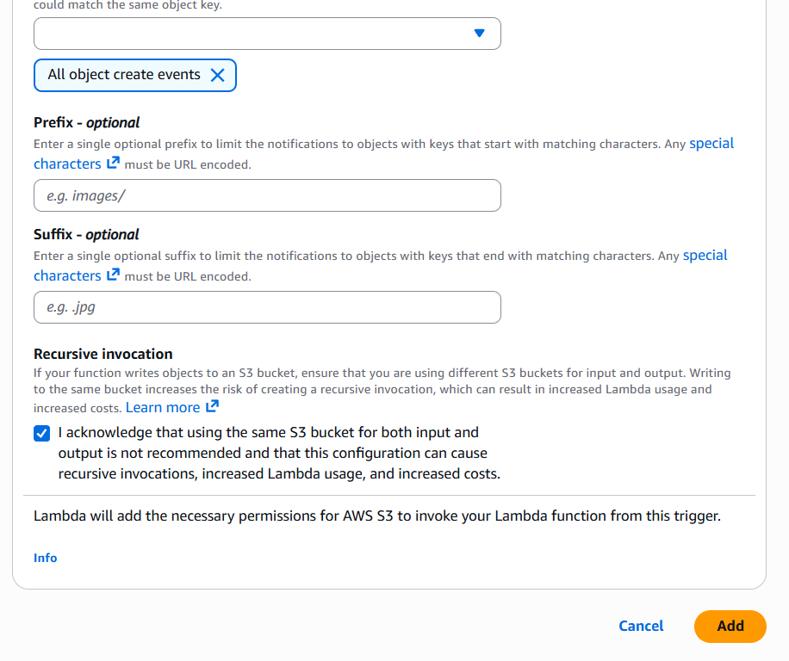

Whenever an object is created in this bucket, run this Lambda function
Click Deploy
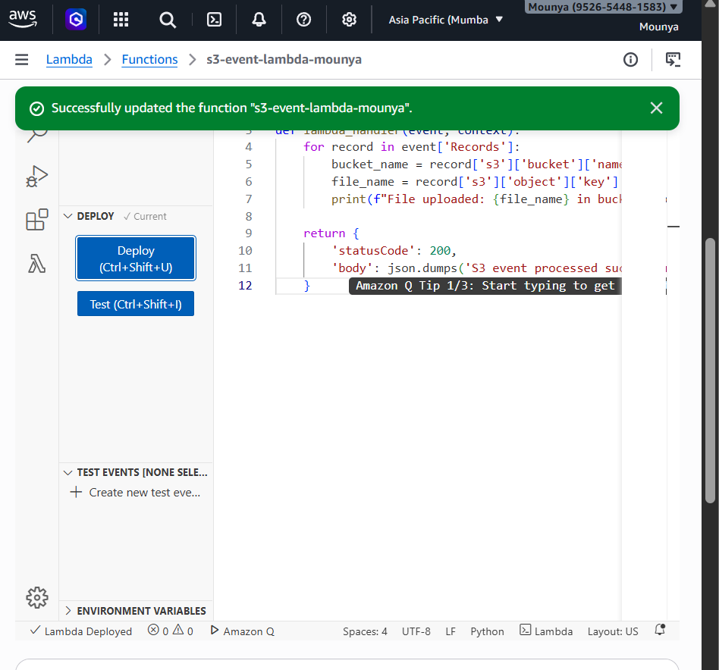
Upload a file to S3
- Go to S3
- Open your bucket
- Click Upload
- Upload any file (test.txt)
- Click Upload

